Jones Valley Resort | Shasta Lake Resorts LP Reservations 530 275 7950  22300 Jones Valley Marina Dr. Service Dept. 530 275 7955  Redding, CA 96003 www.houseboats.com

Royal Star

Operating Manual

Table of Contents
.
.
.
.
.
.
.
.
.

Starting the Boat 1
Driving Techniques 2
The Generator - AC Electrical Power System 3
Generator - Main Breaker 4
The Water System 4
The Propane System 4
Swamp Cooler and Heaters 4
Vessel Appliances …… 5
Barbeque 5
The Septic System 5
Water Slide 6
Safety 6
Contacting The Marina 6
Troubleshooting 7
Returning to the Marina 7
Nautical Terms 8
Royal Star Specifics 8

Starting the Boat
Before Turning the Key:
- Reduce the noise level; turn off the stereo during the engine start-up process.
- Post an observer on the aft deck to watch for people in the water, approaching watercraft, and other obstacles. The driver and observer must communicate.
- Turn on the Blower switch at the helm panel.
- Run the blower for 4 minutes prior to the next step.
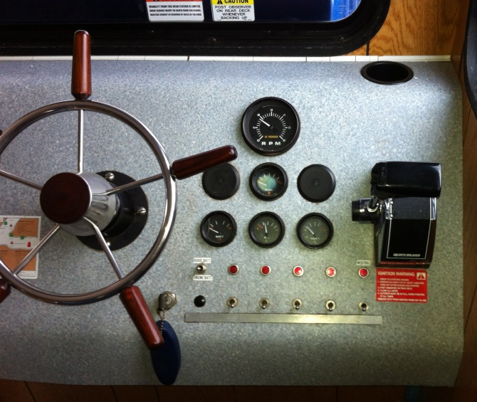
Throttle Position
- Put the throttle lever in the center / neutral position. And turn the key on.
Control Button
This is the large round button located at the base of the throttle lever.
- Press in and hold while moving the throttle lever forward. The gears will not engage, and the drive indicator light will stay lit Release the button.
- With the light on - give the engine some gas by moving the throttle lever to full throttle and back to forward idle. Push the lever forward again - between idle and full throttle. Forward idle is the first lever position forward. Reverse idle, first position back.
- Continue with hand on throttle lever.

Now turn the key clockwise to start the engine.
.

After the Engine has started
Immediately after starting the engine, the drive indicator light (neutral) will be on because the engine is still in neutral. At this point, the throttle lever only affects the idle speed of your houseboat motor.
- Check to make sure the blower is switched off.
- Allow the engine to warm up to 160 degrees.
- Put the throttle lever in the center position.
- Pull the throttle lever back - to back up. Push it forward - to go forward.
Note: Maintain observer position on aft deck until the boat is clear of the shore or dock and traveling forward in open water.

If the Engine will not start
- Is the neutral light on? If not, begin again at step 5 above.
- Check your fuel gauges. You may be out of gas.
- The engine may be flooded. Try again in fifteen minutes.
- If no power, the start battery may be dead.
Note: Do not hold the key down for more than 30 seconds or you may damage the starter.

Shutting down the engine

Put the throttle lever in the center neutral position prior to shutting down.

Turn the key counter-clockwise to shut off the engine.

1

Driving Techniques
Think Ahead. Be Calm. Be Safe. It’s Your Responsibility!
Key to safe handling of this boat is anticipation of speed and direction well in advance.
- SAFETY - Always use an observer on the aft deck when backing up, making turns in tight places or heavy traffic.
- SPEED - Maintain a slow, safe speed. Built for comfort – not for speed!
- BIG BOAT = BIG TURNS - The faster you go, the wider your turn will be.
- SHIFTING - Shift slowly between forward and reverse. Shifting quickly may stall the electronic shifting unit, and render the boat without directional power.
- DEBRIS - Always watch for debris in the water. If it is unavoidable, place the drive in neutral and coast past the object.
- WIND - Whenever possible, navigate into the wind.
- BRAKES - Think of reverse as your brakes. To slow your forward motion, anticipate and slowly shift into reverse.
- TIGHT AREAS - To turn the boat in a tight area;
- Go forward slowly. Then move the throttle to center (disengaged) position. While in the center position turn the wheel in the opposite direction. Slowly shift to reverse and briefly rev the engine. Then, return throttle to center position while turning the wheel back to the direction you want to go. Shift into forward and briefly rev the engine.
- Repeat this forward/reverse method until you have made your turn.
- If you lose control of the boat, try to stay calm. The worst you will probably do is damage the propeller. If the prop is damaged, the boat will vibrate in drive.

NOTE: If the propeller is damaged, secure the boat to shore. Turn off the engine and contact the marina. 530.275.7955

Your houseboat must be secured to shore (at least) every evening. Choose a good location protected from wind. Your landing area must have at least one houseboat length on both sides so you have enough maneuvering room.

2

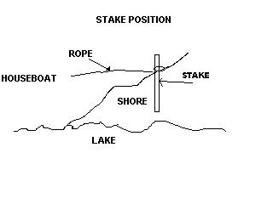
Staking Your Houseboat to Shore
- Choose a landing spot that is not too rocky so you will be able to drive your stakes into the ground. You need a shoreline that is steep enough so the bow of your boat will reach land before the bottom of the pontoons do.
- Proceed at forward idle straight toward the shore. As you near the shoreline, use reverse to soften the landing.
- After landing, steer straight into the shore with throttle forward at +/- 2,000 rpm. This will keep the houseboat perpendicular with the shoreline as a crewmember drives the stakes into the ground and secures the lines. Both lines are to be secured from the rear of the vessel to stakes at 45 degree angle.
- The captain remains at the helm with the engine running and throttle forward until the entire tie-down process is complete.
Note: Check your lines and the lake level each morning and evening. You will need to adjust the houseboat and the tie lines.

Backing off the shore or leaving the Marina
- Post an observer on the back deck. Run the blower 4 minutes.
- Quiet the noise level, and turn off the stereo.
- Relocate personal watercraft, and anything else that is tied to the houseboat.
- Start the engine and allow it to warm up to 160 degrees.
- Engage the drive by pulling the throttle lever back to the center position. Throttle forward at about 2,000 rpm to hold the boat in place.
- Untie the lines and secure them to the bow of the vessel. Put the ramp in place.
- Remember to stow the 4 stakes and hammer on board.
- Sound your horn three times and carefully throttle into reverse. Do not start your turn until you are in open water.

If the houseboat is stuck on shore
Loosen the bow from the shoreline by wagging the tail of the boat. Do this while in forward. First steer all the way to the left until the boat is at a 45 degree angle to the shoreline. Then steer all the way to the right, to a 45 degree angle. Do this a few times. This should “walk” the pontoons down off the shore. Put the boat in reverse and back straight off the shoreline slightly increasing the rpm.
Note: If you are unable to get the houseboat off the shore with this method, contact the marina. 530.275.7955.

The Generator - AC Electrical Power System
The generator is the power source for the 110-volt system. The switches are located near the galley sink.

Starting the Generator
- Flip on the generator blower switch and run for a minimum of 4 minutes.
- To start the generator, press and hold down the “On” switch for a few seconds to crank over the generator. When the light shines steady, release the switch. If the light goes out, the generator has stopped.
- Turn off the blower after generator has started.

If the generator will not start

The engine may be flooded. Try again in fifteen minutes.

Stopping the Generator
Press and hold down the “Stop” switch. The light is off when the generator is off.

3

Generator - Main Breaker
There is a main breaker located on the generator. It controls the power to the 110 volt system. If this breaker is tripped - the appliances and outlets will not work.

Check or Reset the Main Breaker
- Secure the houseboat in a safe location. The houseboat engine and the generator must be off to ensure safety of the person checking the breaker.
- Access the generator below the aft deck by lifting the motor pod hatch to the full vertical position. Have a buddy help lift and hold the hatch upright.
- There is only one breaker at the generator. If tripped, the breaker switch will be in the off position. Flip the switch to reset the breaker.

The Water System

There are two sources of water on the houseboat;
Fresh Water - This is to be used only for drinking and cooking. The potable (fresh) water tank is filled with well water. Each sink has the distinctively shaped upside down ’J’ faucet clearly marked “Fresh Water”.
Lake Water - Lake Water is plumbed for all other use - except the ‘J’ faucets. This includes; deck faucets, standard sink faucets, water heater, shower heads and tub faucets, waterslide, and the toilets. This water is drawn from the lake – right under the vessel. Do not drink from the lake water faucets!

If the faucet marked “Fresh Water” is not working
- Check that the switch is on. Switch is near the galley sink.
- With the fresh water faucet on, you will hear the hum of the fresh water pump.

If the faucet marked “Lake Water” is not working
- Check that the switch is on. Switch is near the galley sink.

The Propane System
The water heater, refrigerators, cabin heaters, barbeque, stovetop and oven use propane. The boat has two LPG tanks that hold approximately 7 gallons each. The tank regulator will switch automatically from the empty tank to the full tank.

Note: If there are any issues, please call the Marina Service Department. 530.275.7955

Swamp Cooler and Cabin Heaters
The generator must be on to operate the swamp cooler. The unit must be OFF prior to starting the generator. The cooler controls are located on the face of the unit. It may take a few minutes for the unit to work effectively.
To use the cooler
- The unit must be OFF. If not, the generator breaker will trip.
- Turn on the generator. Allow the generator to warm up before starting cooler.
- Set the ON/OFF selector switch to high or low cool position.

If the swamp cooler will not operate
- Check the main breaker at the generator.
- Make sure the generator is on.
To use the heater
Follow the instructions on the unit.

4

Vessel Appliances
The generator must be on while using the electrical outlets, the microwave, or the swamp cooler. With the generator on, the appliances operate in the same manner as a household appliance.
The refrigerators, stovetop / oven, water heater, and the cabin heaters are powered by LPG and may employ the 12 volt battery system for ignition.

If one of the items will not work
- Check that the generator is on.

If there is no hot water
- Check to see if LPG tanks are on.
- Check to see if you are out of propane.
- Check to see if the pilot flame is lit.

Barbeque
FOR OUTDOOR USE ONLY - Operates like a residential gas barbeque.

Igniting the grill
- Open the lid during lighting.
- Start with all valves in the OFF position.
WARNING: Do not lean over the open barbeque! Keep your face and body at least one foot away from match light hole when lighting the barbeque.
- Push Front Burner control knob down and turn to START / HI.
- Push the igniter button several times, so it clicks each time.
WARNING: If the burner does not light, turn the Front burner control knob to OFF. Wait 5 minutes to let the gas clear before you try again. Open lid.
- After the FRONT burner is lit, you can turn on the other burners.

To extinguish
- Push down and turn each burner control knob clockwise to the OFF position.
- Shut off the gas supply valve located near the BBQ unit.

The Septic System
The houseboat is equipped with a 600-gallon septic holding tank. The vessel holding tanks are pumped out and treated after each voyage. Marine septic systems are for human waste and biodegradable toilet tissue only. A service fee is charged to clear plugged systems.

The Head - Toilet
To flush the head, depress the foot pedal at the base. To fill the bowl with water, lift up on the foot pedal. Be sure to fill the bowl with water prior to each use. The vessel sewage system relies on liquid for treatment. Please remember to flush with plenty of water each time you use the head.

If the bathrooms smell
- Open the window in the bathroom, and close the bathroom door.
- Fill the toilet bowl with water, then flush.
- Repeat this procedure a few times. Leave the window open with the door closed to allow the room to air.
- If the bathrooms still smell after completing the above procedure a few times, you may need to have your tank pumped out and retreated.

5

Water Slide
Be sure to wet the surface of the water slide before use. There is a faucet at the top of the slide for this purpose.

If the faucet at the top of the waterslide is not working
- Check that the Lake Water switch is on.

Safety
Familiarize yourself with the safety equipment on your vessel before you might need to use it. Time is very precious during an emergency.

Carbon Monoxide Detector - Located low on the wall in the hall area. If the alarm sounds, account for each person on the boat, open up all the doors and windows, get onto shore and call the marina immediately (530) 275-7955.

Distress Flag - Located in the galley drawer. In an emergency, display the flag on your houseboat where other boaters can see it.

First Aid Kit - Located in the galley drawer with the Distress Flag.

Fire Extinguishers - There are 3 fire extinguishers on the houseboat; one is located at the helm, and two are on the exterior rear wall of the cabin.

To use, pull the pin, aim at the base of the flame, and sweep from side to side.

Personal Flotation Devices - (PFDs/Life Vests) Stacked and stored inside the forward gaucho cabinets, at floor level.

Throwable Device - The throw cushion is located beside the helm seat. It is a flotation device that may be tossed to a person in a water emergency.

Contacting the Marina
In this binder and on your boat, there is a detailed map of the lake. Refer to the map often to know your exact location. Before contacting the marina, please know your location and vessel number.
If there is a problem, please contact the Marina (530) 275-7955. Describe the problem in detail, and the steps you have taken so far to remedy the problem.
If a service technician is to respond to your boat, clear and detailed information will help us resolve an issue quickly.

You must stay with the boat at that location until the technician arrives. Too often, houseboat guests requesting assistance are not at the given location.

note: GPS coordinates might not be exact – but, they could be helpful.

6

Troubleshooting
This quick troubleshooting guide addresses most common problems.
Problem | Possible Causes | Possible Solutions
Engine will not  turn over or start | Boat is not in neutral | Place drive in neutral
 | Battery issue | Contact Marina (530) 275-7955
 | Low fuel; Check gauge | Check gauge
Engine starts, then dies | Flooded carburetor | Wait 15 minutes; try again
Boat vibrates while driving | Damaged prop | Get to shore. Turn off engine.  Contact Marina (530) 275-7955
Generator will not  turn over or start | Battery issue | Contact Marina (530) 275-7955
 | Low fuel; check gauge | Check gauge
Generator starts, then dies | Flooded carburetor | Wait 15 minutes; Try again
Refrigerator will  not get cold | Over-filled; Opened too often | Rearrange / keep closed
 | Propane issue | Make sure LPG tank is on
 | Battery charge is too low | Turn generator on
Lake Water faucets  are not working | Switch is off | Flip switch on
 | Lake Water pump | Switch Lake Water pump on
 | Air in the line | Bleed air from line
Fresh Water “J” faucets  are not working | Switch is off | Flip switch on
 | Air in the line | Bleed air from line
An appliance is  not working | Generator needed – and is off | Turn generator on
 | Battery charge is too low | Turn generator on
 | Main breaker has tripped | Reset generator main breaker
 | Propane issue | Make sure LPG tank is on

Returning to the Marina
If you are checking out, we recommend that your gear is packed, and the decks washed prior to arrival at the marina. This leads to a more efficient checkout.

When returning to the marina, we will see your boat at the log boom and we will come out to park it at the marina. Upon arrival at the dock, please hold your gear on the front deck of the boat. Do not place anything on the dock.

The QuadSquad is assigned to help transport your gear.

After the houseboat is cleared of your belongings and you have completed a general clean up, our crew will fuel the houseboat. A crew member will conduct a thorough check of the boat, and report the status to the marina store.

The checkout is complete after fuel and final charges are paid in the marina store.

7

Nautical Terms
Aft – The area of a compartment on a vessel or an object on a vessel that is closest to the stern (rear) in relation to another area or object on the vessel. The aft wall of the cabin is the wall closest to the stern.
Bow – The front of a vessel.
Service Call – Contacting the marina to request service assistance to your houseboat.
Fore – The area of a compartment on a vessel or an object on a vessel that is closest to the bow in relation to another area or object on the vessel. The fore wall of the cabin is the wall closest to the bow.
Flying Bridge – The helm on the upper deck of a vessel.
Galley – The kitchen on a vessel.
Head – The toilet on a vessel.
Helm – The area from which the boat is piloted.
Lines – Often referred to as rope. Technically, large quantity of rope is spooled. Rope becomes line when cut, prepared and put to use. A piece of rope is made into a line.
Port – The left side of a vessel when facing the bow.
Starboard – The right side of a vessel when facing the bow.
Stern – The rear of a vessel.
Tachometer – A helm gauge that displays the revolutions per minute of the engine.
Underway – A vessel traveling through the water.
Vessel – A large watercraft.

Royal Star Specifics

The Power System The Water System
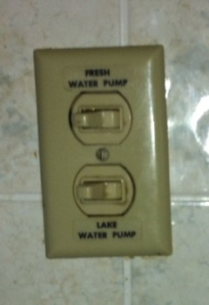

Fresh Water

Pump

Lake Water

Pump

Blower & Generator switches

Electrical Outlet 12v outlet
8

